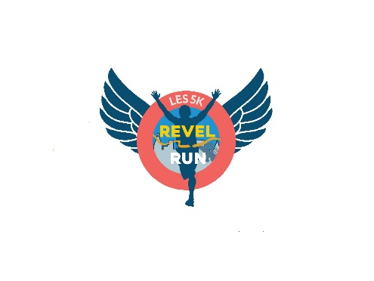
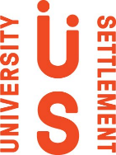

LES 5k Revel Run Sponsorship Form
October 5, 2025
John V. Lindsay East River Park Track

Donor Name (Business or Individual): _____________________________________________
Contact Person (if Business): ____________________________________________________
Address: ____________________________________________________________________
____________________________________________________________________________
Email: ______________________________________________________________________
Phone Number (Optional): ______________________________________________________
Revel Run Contact: ____________________________________________________________

Please check one of the following:
_______ Ultimate Reveler | $2,500
_______ LES Legacy | $2,000
_______ LES Champion | $1,500
_______ Rowdy Reveler | $1,000
_______ Revel Friend |$750
_______ LES Neighbor | $500

Please email this completed form, your company logo, or full name as you’d like to be listed to Ali Margolies at amargolies@universitysettlement.org
Please make checks payable to University Settlement and include Revel Run 2025 in the memo line. Checks can be mailed to:
ATTN: Development
University Settlement
184 Eldridge Street
New York, NY 10002

LES 5k Revel Run Sponsorship Form
October 5, 2025
John V. Lindsay East River Park Track

Ultimate Reveler | $2,500
• Includes ten (10) tickets to participate in the Revel Run.
• Company logo or donor name on event t-shirt.
• Company logo or donor name featured on top tier sponsorship section of event website.
• Company logo or donor name featured on Revel Run’s social media.
• Company or donor acknowledged at the race
• Company’s materials passed out at the race.

LES Legacy | $2,000
• Includes eight (8) tickets to participate in the Revel Run.
• Company logo or donor name on event t-shirt.
• Company logo or donor name featured on sponsorship section of event website and social media.
• Company or donor acknowledged at the race.

LES Champion | $1,500
• Includes six (6) tickets to participate in the Revel Run.
• Company logo or donor name on event t-shirt.
• Company logo or donor name featured on sponsor section of event website and social media.

Rowdy Reveler | $1,000
• Includes four (4) tickets to participate in the Revel Run.
• Company logo or donor name on event t-shirt.
• Company logo or donor name featured on sponsor section of event website and social media.

Revel Friend | $750
• Includes four (4) tickets to participate in the Revel Run.
• Company logo or donor name featured on sponsor section of event website and social media.

LES Neighbor | $500
• Includes two (2) tickets to participate in the Revel Run.
• Company logo or donor name featured on sponsor section of event website.
____________________________________________________________________________________
*Each ticket includes access to the race, warm up activity, bib, and race t-shirt. The non-deductible portion of each ticket is $12. University Settlement Society of New York is a 501c3, EIN # 13-5562374. For more information, please visit www.universitysettlement.org/lesrevelrun
*Ultimate Reveler, LES Legacy, LES Champion, and Rowdy Reveler sponsors will be featured on the event t-shirt as long as the logo or donor name is submitted by September 12th.

